**Q1: Simulation in VISSIM**

1. Network information

Please see the figures below for network information.

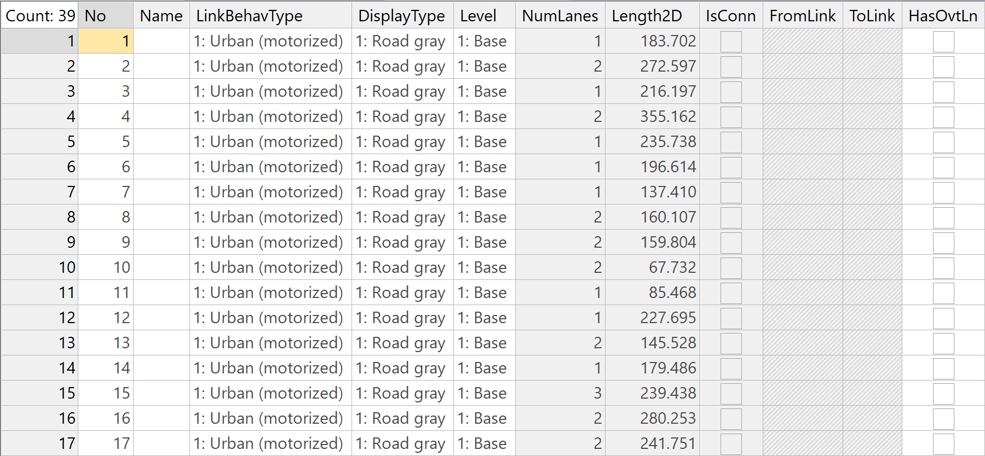

Figure 1 Link list

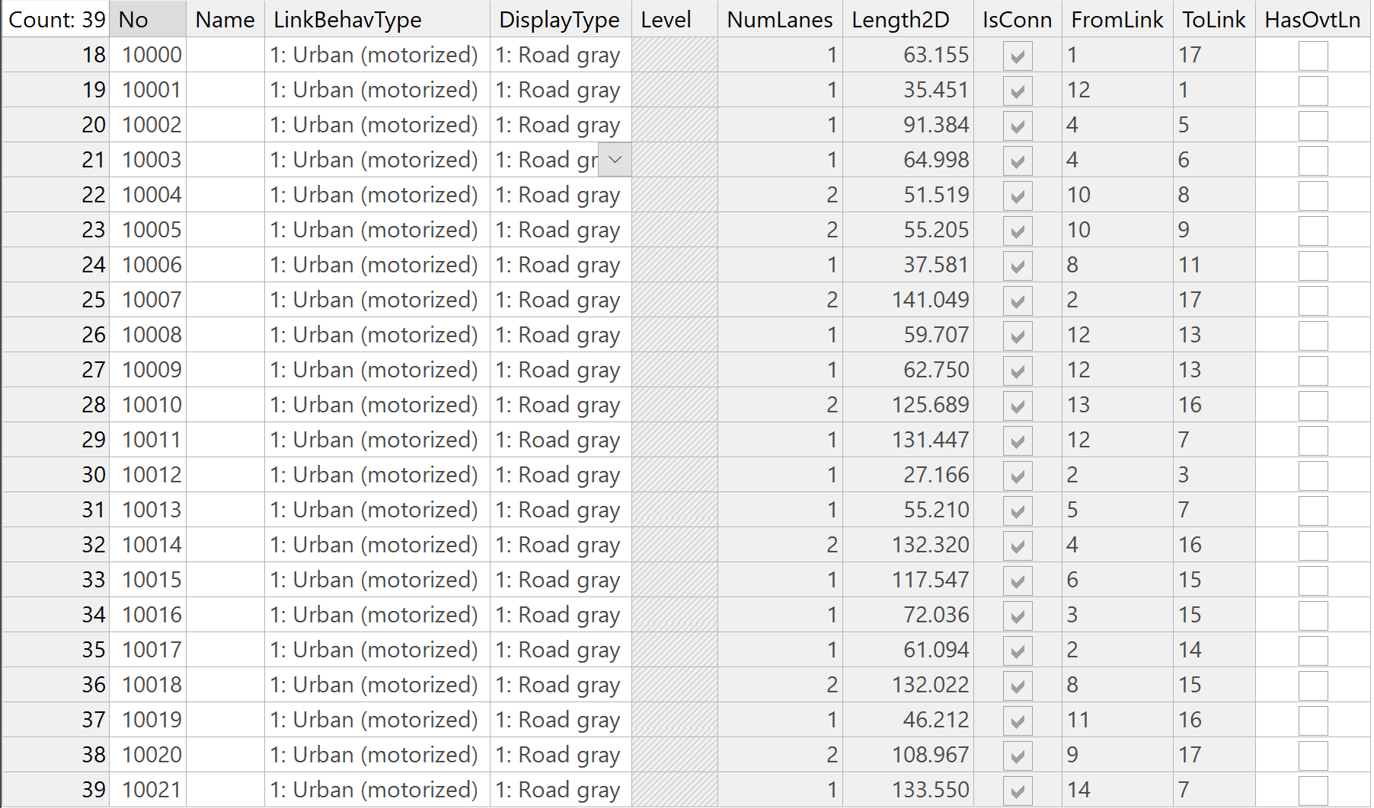

Figure 2 Connector list

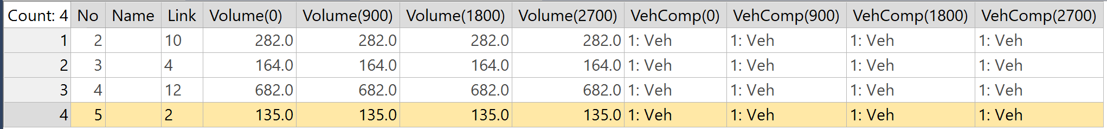

Figure 3 Vehicle inputs list

1. Travel time Evaluation

Please see the figure below for simulation results

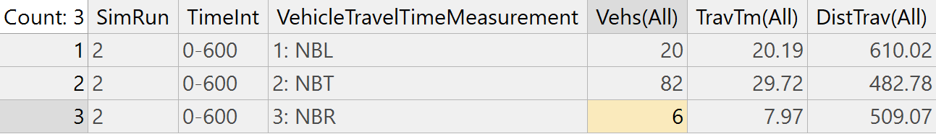

Figure 4 Vehicle travel time results

**Q2: Deriving Greenberg’s macroscopic model from GM-3 car-following model**

GM-3 car-following model:

${\ddot{x}}_{n+1}\left(t+∆t\right)=\frac{α_{0}}{x_{n}\left(t\right)-x_{n+1}\left(t\right)}\left[{\dot{x}}_{n}\left(t\right)-{\dot{x}}_{n+1}\left(t\right)\right]$ (1)

Integrating on both side

${\dot{x}}_{n+1}=α_{0}ln\left(x_{n}\left(t\right)-x_{n+1}\left(t\right)\right)+C_{1}$ (2)

$x_{n}\left(t\right)-x_{n+1}\left(t\right)$ denotes the space between two vehicles, which can also be represented as $1/k$, then we have

$u=α_{0}ln\left(1/k\right)+C_{1}$ (3)

Let $α_{0}lnC_{2}$ be substituted for constant $C_{1}$, then

$u=α_{0}ln\left({C_{2}}/k\right)$ (4)

Since when $k=k_{j}$, $u=0$:

$0=α_{0}ln\left({C_{2}}/{k_{j}}\right)$ (5)

$C_{2}=k_{j}$ can by obtained by solving the equation (5) above. Finally, equation (5) can be written as

$u=α_{0}ln\left({k_{j}}/k\right)$ (6)

**Q3: Deriving Q=KV from Little’s law**

Little’s law:

$\overline{L}\left(t\right)=\frac{A\left(t\right)}{t}×\overline{W}\left(t\right)$ (1)

To derive the relationship between three basic parameters, treat $\overline{L}\left(t\right)$ and $\overline{W}\left(t\right)$ as number of vehicles on the roads and average travel time respectively. Assuming the length of the road is $L$, then we have

$L/{\overline{L}\left(t\right)}=L/{\left(\frac{A\left(t\right)}{t}×\overline{W}\left(t\right)\right)}$ (2)

using equation Little’s law.

Further,

${\overline{L}\left(t\right)}/L={\left(\frac{A\left(t\right)}{t}×\overline{W}\left(t\right)\right)}/L$ (3)

For the left side of equation (3), ${\overline{L}\left(t\right)}/L=K$, where $K$ denotes the density. For the right side, $\frac{A\left(t\right)}{t}=Q$, where $Q$ denotes the arrival rate. Meanwhile, ${\overline{W}\left(t\right)}/L=1/V$, where $V$ means the average speed of all vehicles. So, we can obtain $K=Q/V$, then $Q=KV$.